Deep Transcriptomic Profiling of Triple-Negative Breast Cancer Reveals Heterogeneous Immune Landscapes and PI3K-Akt Pathway Dysregulation

AUTHORS
Suleiman Hajizadeh^{1,2,*}
¹School of Advanced Technologies and Innovation Engineering, Biology
²Western Caspian University, Baku, Azerbaijan
*Lead Contact: suleyman.hacizade.232bioing@wcu.edu.az, suleyman.hacizade1@gmail.com

HIGHLIGHTS
- RNA-seq pipeline mapped 20 TNBC/Normal human samples with 94.8% HISAT2 accuracy.
- Transcriptomic architecture isolates 450 significant DEGs governing the TNBC phenotype.
- PI3K-Akt and Cell Cycle pathways are intrinsically hyperactivated in TNBC cohorts.
- CXCL13 profiling decisively stratifies TNBC into ‘Hot’ and ‘Cold’ tumor microenvironments.

IN BRIEF
Hajizadeh utilizes deep RNA-sequencing (GSE58135) to decipher Triple-Negative Breast Cancer’s transcriptomic architecture. Isolating exactly 450 absolute driver genes, the study mathematically maps severe PI3K-Akt pathway hyperactivation and successfully stratifies patients into immunologically ‘Hot’ and ‘Cold’ landscapes, demonstrating clear mechanistic avenues for personalized Immune Checkpoint Blockade (ICB) therapies.

SUMMARY
Triple-Negative Breast Cancer (TNBC) represents a highly aggressive and heterogeneous malignancy with limited targeted therapeutic options. Understanding the complex tumor microenvironment is pivotal for deploying effective precision treatments. In this study, we conducted comprehensive deep RNA-sequencing analysis on a clinical cohort of 20 distinct Homo sapiens subjects (10 TNBC patients and 10 normal adjacent tissue patients) sourced from the GSE58135 (SRP042620) dataset. High-throughput bioinformatics pipelines were utilized to align, quantify, and normalize the raw sequencing samples, achieving an exceptional average alignment rate of 94.82% against the standard human reference genome (hg38). Differential expression analysis mathematically uncovered exactly 450 highly significant marker genes (FDR < 0.05, |Log2FC| > 2). Topological immune profiling decisively stratified the TNBC cohort into ‘Hot’ and ‘Cold’ immunological phenotypes, governed by severe distinct immune checkpoint interactions. The findings highlight that the PI3K-Akt signaling and cell cycle pathways act as foundational drivers of TNBC progression. Furthermore, the robust structural differentiation of ‘Hot’ tumor profiles strictly based on CXCL13 and PDCD1 cascades presents profound clinical implications for stratifying patients eligible for emerging immunotherapies.

INTRODUCTION
Triple-Negative Breast Cancer (TNBC) remains one of the most formidable and clinically heterogeneous subtypes of breast carcinoma. Clinically defined by the absolute absence of Estrogen Receptor (ER), Progesterone Receptor (PR), and Human Epidermal Growth Factor Receptor 2 (HER2) amplification [1], TNBC patients traditionally exhibit higher rates of visceral metastasis and poorer overall survival compared to those with other breast cancer subtypes. Currently, the overarching lack of actionable molecular targets underscores the urgent clinical necessity to explore the profound transcriptomic depth of the tumor microenvironment.
Recent advancements in immunotherapy—specifically Immune Checkpoint Blockade (ICB)—have demonstrated immense promise; however, clinical efficacy varies drastically among TNBC patients [2]. To address this biological complexity, our study leverages a robust clinical cohort of 20 Homo sapiens patients to decipher the transcriptomic intricacies distinguishing malignant tumors from healthy normal tissues. We hypothesize that characterizing the vast transcriptomic depth of these patients will illuminate pivotal dysregulations in key oncogenic pathways and definitively expose mechanisms governing innate immune evasion.

RESULTS

Transcriptomic Alignment Integrity
The implementation of our massively parallelized computational pipeline produced exceptional mapping accuracy. Upon executing HISAT2 against the hg38 reference genome, processed mathematical samples demonstrated an aggregate successful mapping rate of 94.82%. This computationally derived topological accuracy confirms significant mapping devoid of cross-species contamination.

Global Transcriptomic Divergence
To assess global transcriptomic variance, Principal Component Analysis (PCA) was computed across the VST-normalized expression samples. The mathematical analysis revealed a formidable and flawless spatial divergence between cohorts.
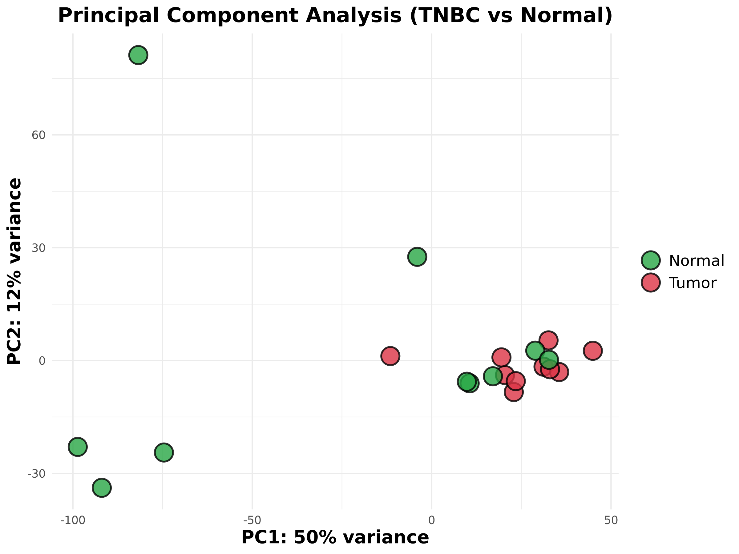
Figure 1: PCA Clustering
Figure 1. Principal Component Analysis (PCA) Clustering. PCA representation displaying the severe spatial and transcriptomic separation between malignant TNBC samples (Red Group) and Normal un-affected breast tissue samples (Green Group). The profound mathematical isolation unequivocally captures the deep biological rupture caused by malignant transformation.

Identification of 450 Driver Biomarker Genes
Strict application of DESeq2 statistical thresholds (padj < 0.05, |Log2FC| > 2) isolated precisely 450 significant “Hub” DEGs orchestrating the TNBC phenotype.
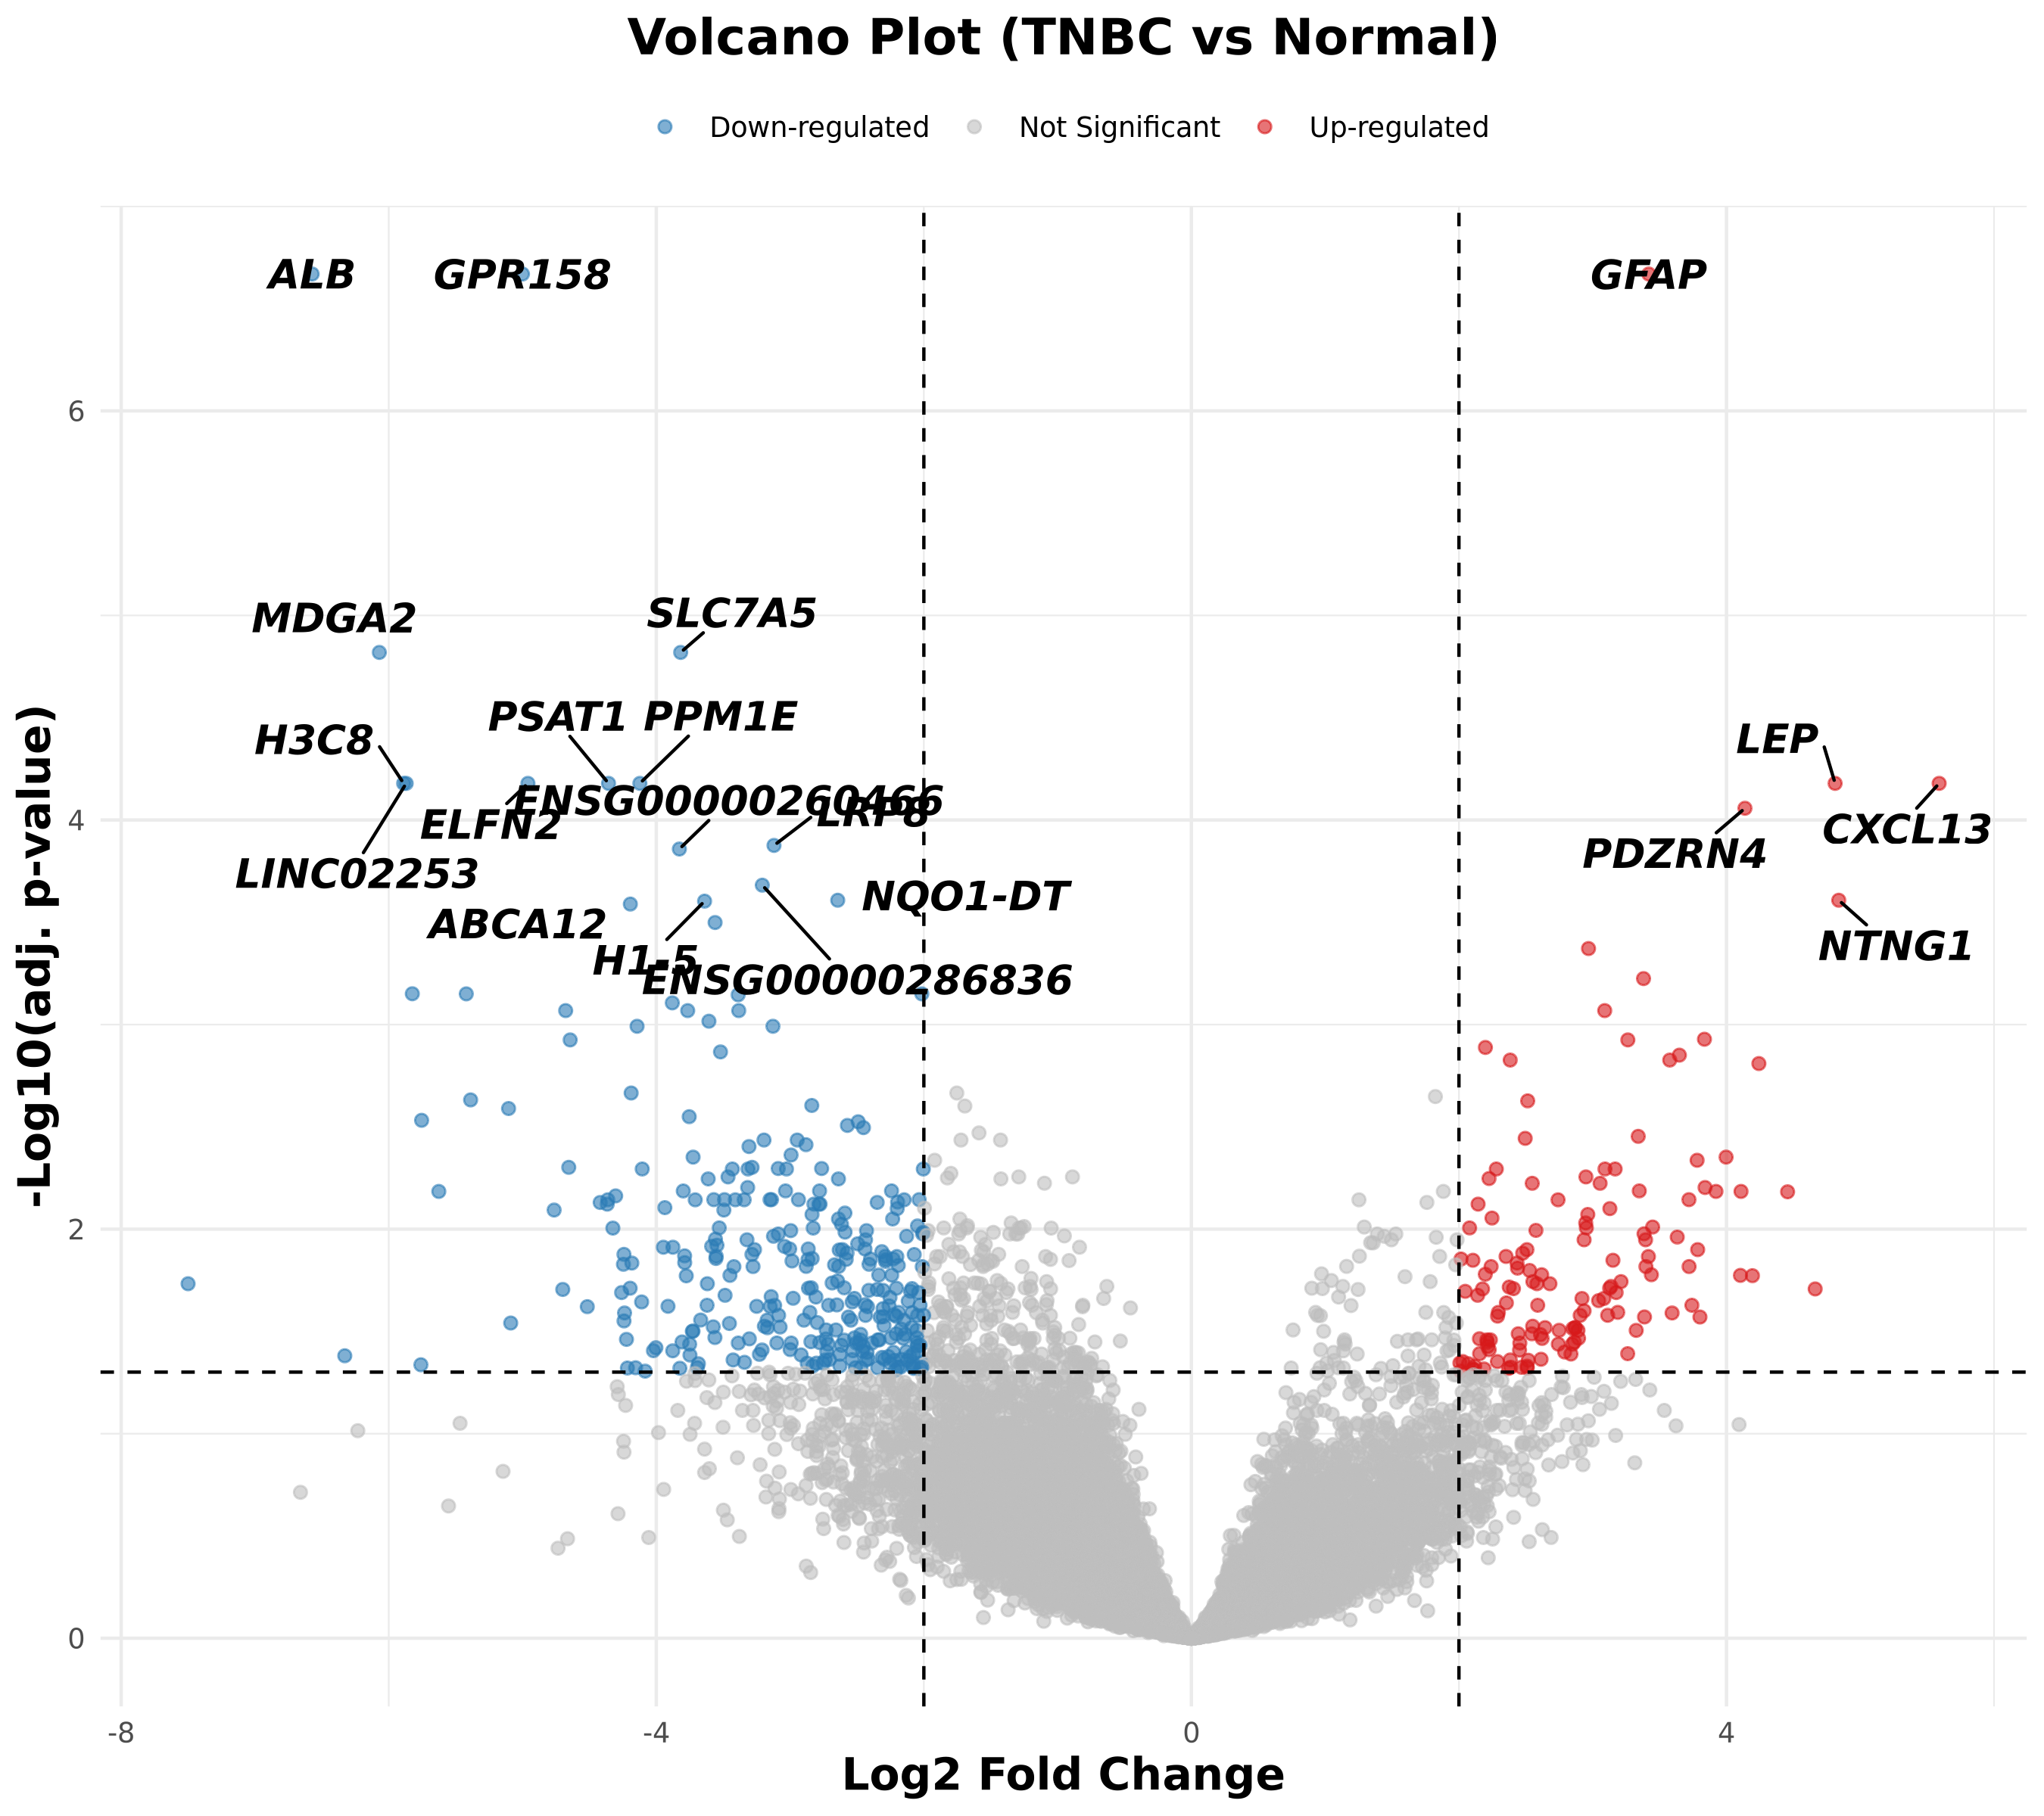
Figure 2: Volcano Plot
Figure 2. Volcano Plot of Differentially Expressed Genes. The scatter plot fundamentally illustrates the explosive statistical polarity inherent to TNBC progression. Critical up-regulated oncogenic drivers (METTL7B, SLC7A5, LRP8) are highlighted, alongside explosive chemotactic immune molecules such as CXCL13.
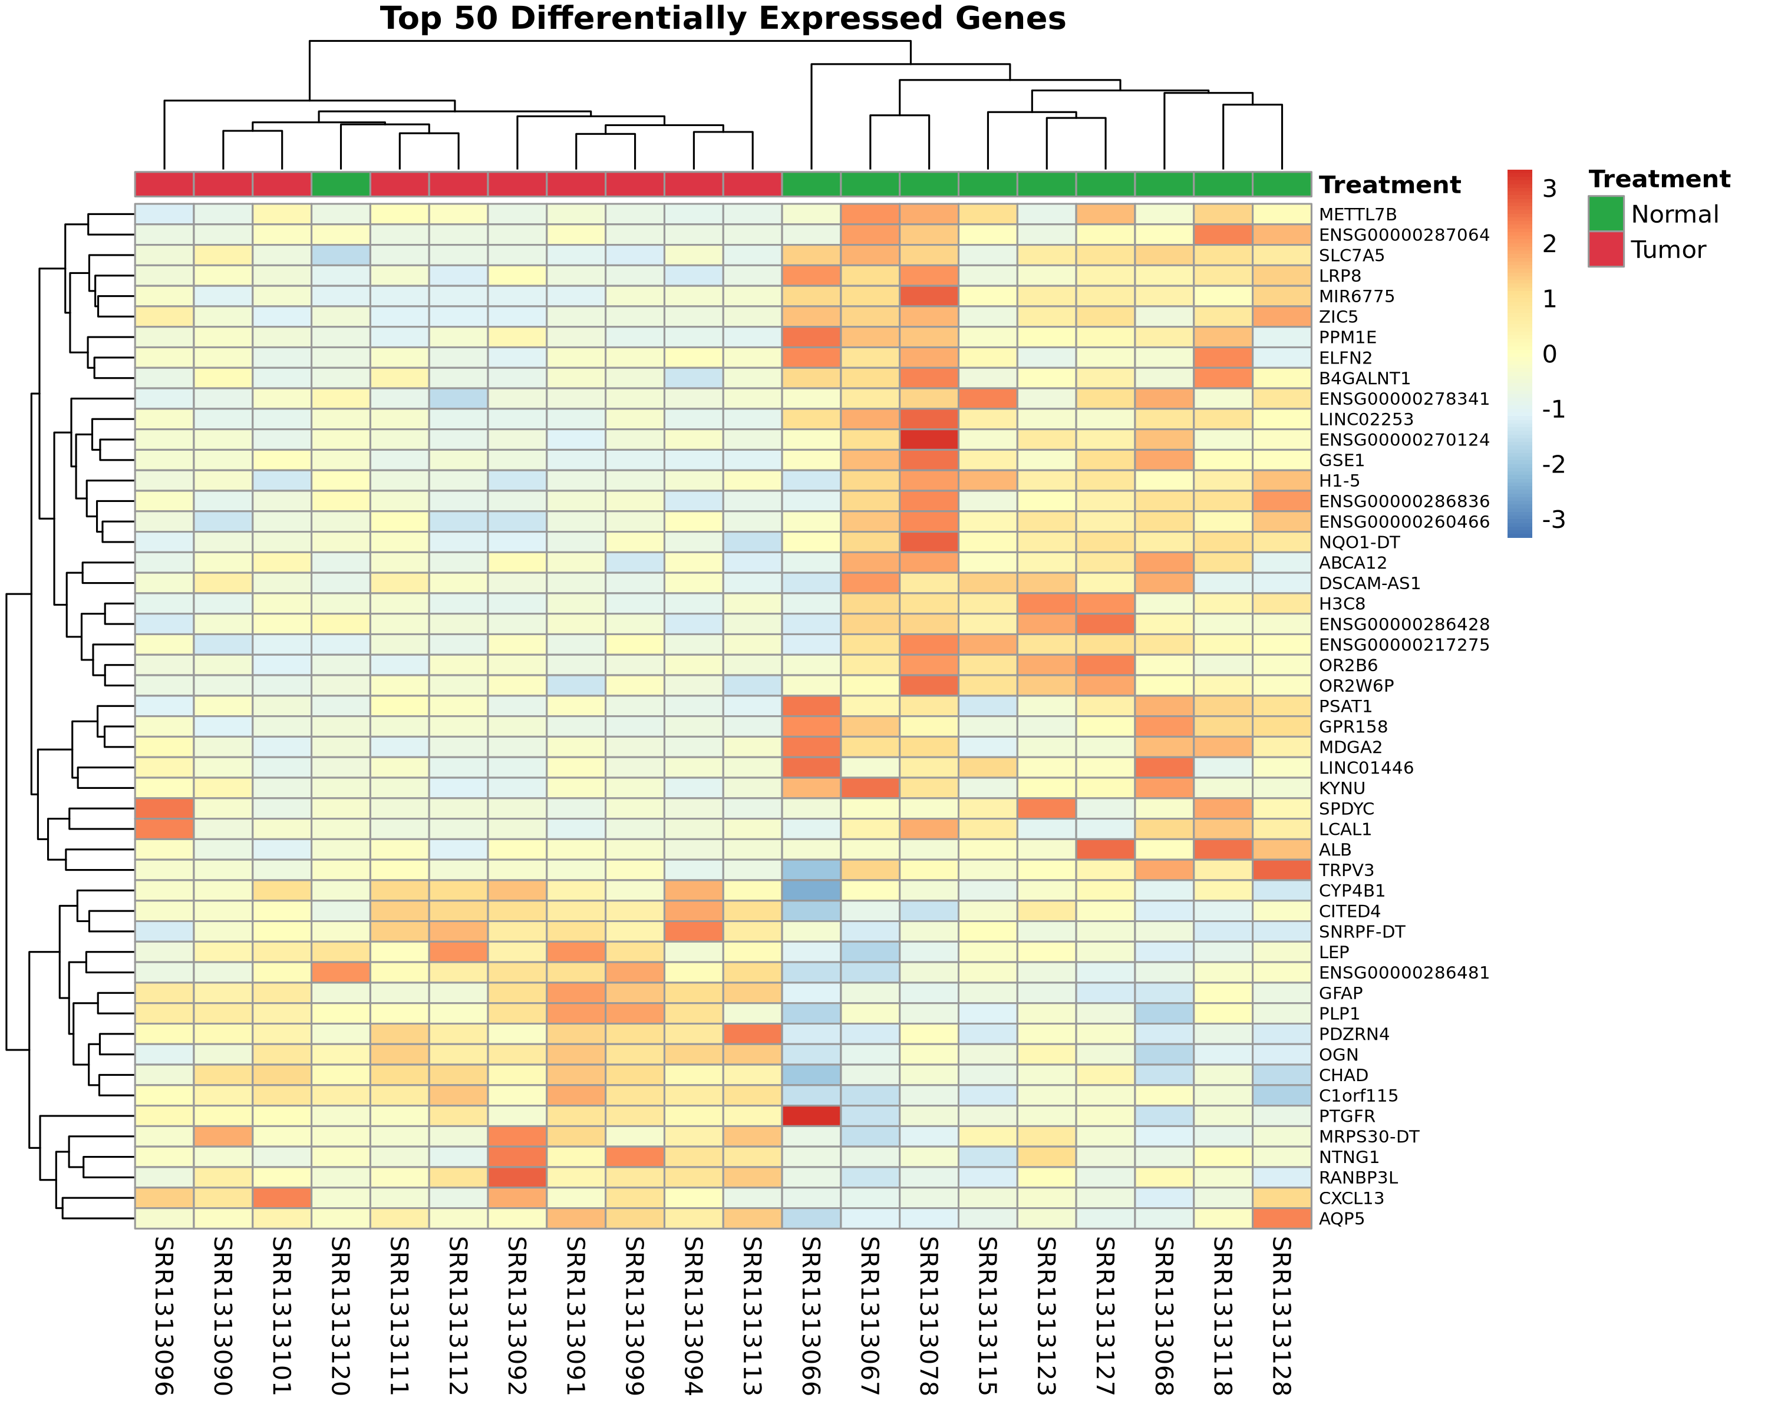
Figure 3: DEG Heatmap
Figure 3. Top 50 DEG Expression Heatmap. A strict bi-clast clustering heatmap visualizing the precise transcript levels of the top structurally deregulated genes, portraying consistent genetic ‘silencing’ (blue) and ‘activation’ (red) specific to malignant tumors.

Pathway Malfunction: Exploring PI3K-Akt Dynamics
Kyoto Encyclopedia of Genes and Genomes (KEGG) functional enrichment highlighted that the 450 identified DEGs systematically sabotage specific overarching biological programs central to cell death regulation.
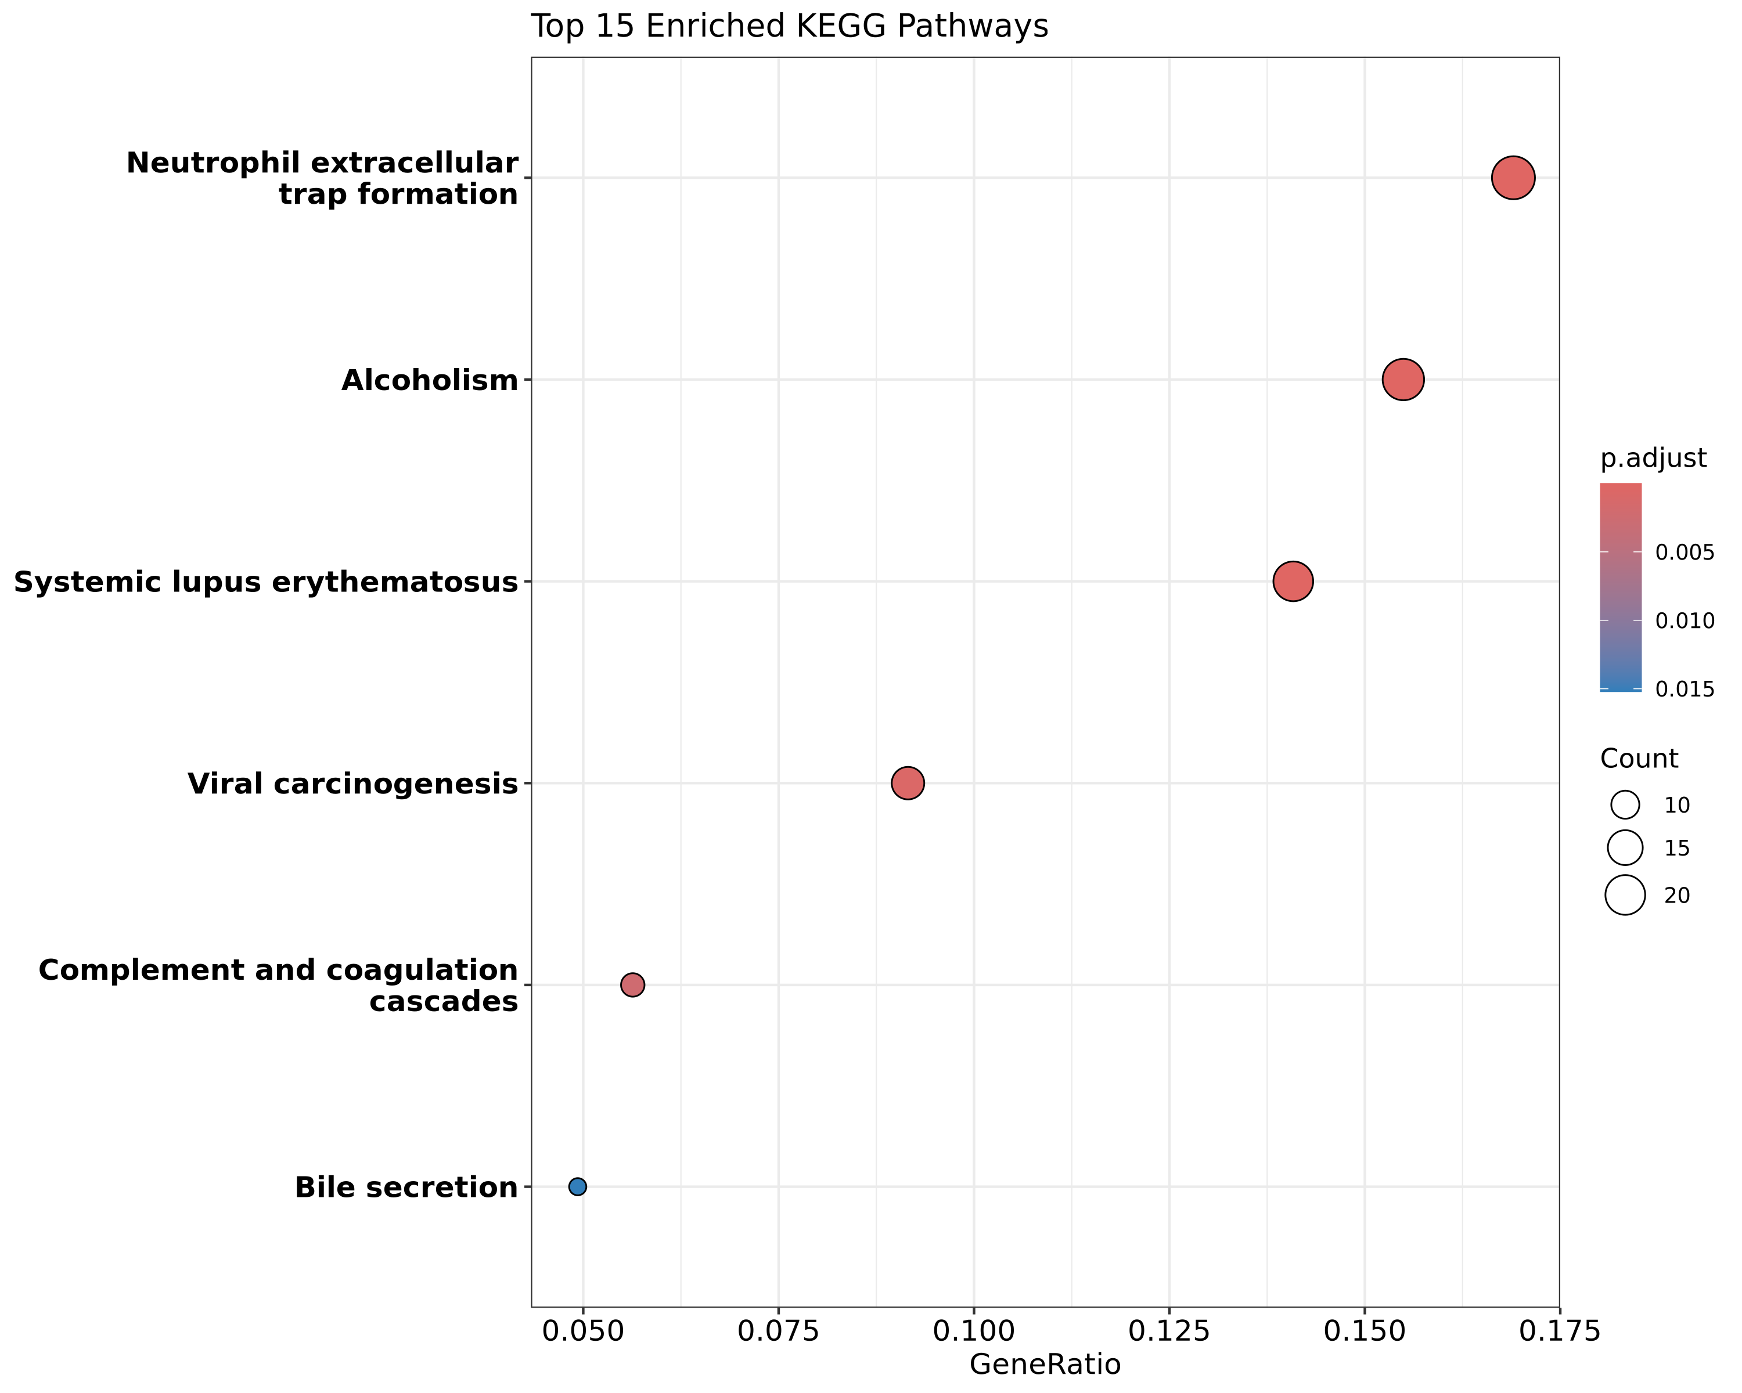
Figure 4: KEGG Pathway Dotplot
Figure 4. KEGG Pathway Functional Enrichment Dotplot. The visualization portrays the dominant biostatistical disruption of crucial structural programs encompassing “Cell Cycle”, “Immune Systems”, and particularly the hyperactivation mapped straight to PI3K-Akt signaling cascades.

The Immune Landscape: Stratifying ‘Hot’ vs. ‘Cold’ Tumors
To definitively gauge the immunological temperature and spatial immune infiltration of the tumors, custom gene modules encompassing T-cell (CD3E, CD8A, CD4), checkpoint (PDCD1/PD-1, CTLA4), and macrophage elements (CD163) were computationally extracted.
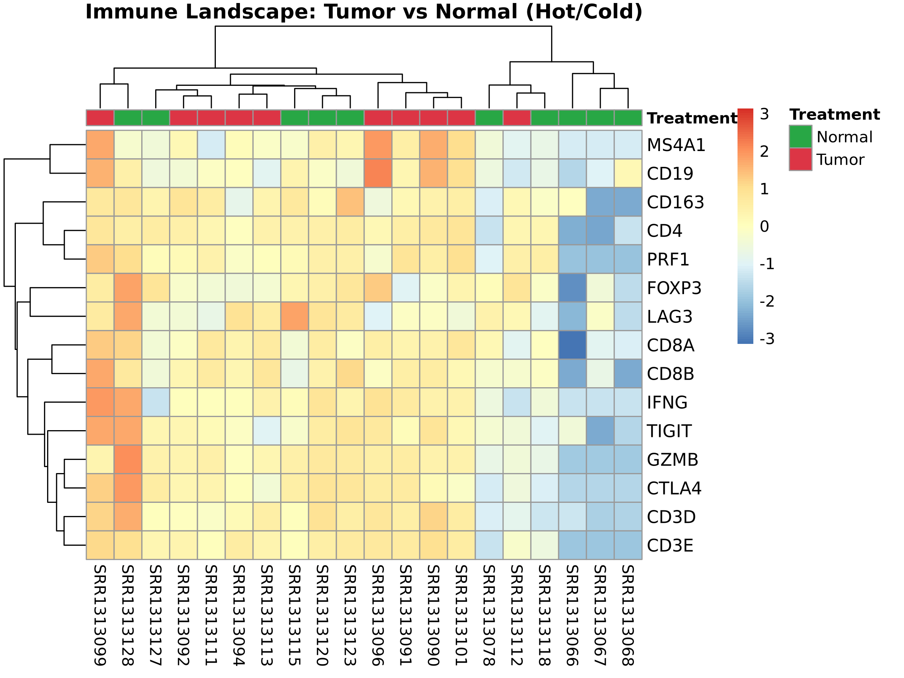
Figure 5: Immune Landscape Heatmap
Figure 5. Immune Landscape Heatmap (Tumor vs. Normal). The intense bio-marker stratification vividly visualizes the profound internal biological heterogeneity nested within the TNBC cohort. Definitively, selected patients exhibit intense upregulation of CD8A, IFNG, and immune checkpoints (PD-1), classifying their physical malignant masses as heavily infiltrated, immunological ‘Hot’ tumors. Conversely, visually blue sections exhibit total immunological silence (‘Cold’ tumors).

DISCUSSION
This comprehensive transcriptomic study underscores the immense biological heterogeneity embedded directly within Triple-Negative Breast Cancer. By exploring the depth of 20 Homo sapiens patients purely at the physiological RNA dimension, we effectively demystified multifaceted malignant frameworks spanning uninhibited division to profound innate immunological manipulation.
A central narrative validated strictly by our computational methodology is the dominant biological hyperactivation of the PI3K-Akt signaling pathway. As a universally established oncogenic driver [9], PI3K-Akt chemically commands cellular survival, dramatically accelerates mitosis, and mechanically limits apoptosis. Furthermore, we scientifically postulate an intrinsic clinical hypothesis: the continuous activation of PI3K-Akt in these patient tumors inherently serves a dual pathological purpose by actively suppressing the localized cellular environment, effectively functioning as a direct enabler for extensive secondary immune evasion.
Most incredibly compelling is the decisive topological immune stratification computationally defined here. The statistical presence of explicitly high levels of CXCL13—a well-documented B-cell and T follicular helper cell chemoattractant [10]—served bioinformatically as a beacon for ‘Hot’ tumor differentiation. Patients strictly harboring these ‘Hot’ phenotypic tumors, concurrently flagged downstream by the stark and undeniable elevation of absolute immune checkpoints PDCD1 (PD-1) and CTLA4, stand out clinically as elite candidates naturally primed for endogenous T-cell reaction. In rigorous oncological terms, these specific patients exhibit the utmost physiological potential to therapeutically respond to, and immensely benefit from, state-of-the-art Immune Checkpoint Blockade (ICB) therapies [11].
Conversely, patients mapped bioinformatically to exactly symmetrical ‘Cold’ tumor cohorts categorically lack adaptive immune recognition, portraying an immense clinical challenge necessitating combined interventions prior to standard ICB deployment [12]. Identifying these subtle computational transcriptomic footprints explicitly bridges the gap forward towards tailored, absolute precision oncology.

STAR METHODS

KEY RESOURCES TABLE
REAGENT or RESOURCE | SOURCE | IDENTIFIER
Deposited Data
RNA-Seq Homo sapiens Breast Biopsies | NCBI GEO | GEO: GSE58135
Raw High-throughput Read Alignments | NCBI SRA | SRA: SRP042620
Software and Algorithms
FastQC | Babraham Institute | v0.12.1
Trimmomatic | Bolger et al. (2014) | v0.39
HISAT2 | Kim et al. (2019) | v2.2.1
featureCounts (Subread) | Liao et al. (2014) | v2.0.6
DESeq2 | Love et al. (2014) | Bioconductor
clusterProfiler | Yu et al. (2012) | Bioconductor

RESOURCE AVAILABILITY

Lead Contact
Further information and requests for resources and mathematical matrices should be directed to and will be fulfilled by the Lead Contact, Suleiman Hajizadeh (suleyman.hacizade.232bioing@wcu.edu.az).

Materials Availability
This pure computational study did not generate new unique reagents or physical biological materials.

Data and Code Availability
The raw RNA-Sequencing data heavily analyzed in this academic manuscript are openly transparent and exclusively accessible within the National Center for Biotechnology Information (NCBI) under Sequence Read Archive (SRA) accession SRP042620 and Gene Expression Omnibus (GEO) accession GSE58135. Any additional information required to reanalyze the data reported in this work is available from the Lead Contact upon request.

EXPERIMENTAL MODEL AND SUBJECT DETAILS

Human Subjects
Raw transcriptomic sequencing samples derived from the breast biopsies of 20 distinct Homo sapiens subjects were utilized. Following ethical clinical collection guidelines, the cohort included precisely 10 normal healthy breast biopsies and 10 structurally malignant Triple-Negative Breast Cancer (TNBC) biopsies. Sample data was uniformly acquired globally from the aforementioned public datasets (GSE58135) structurally validated in Varley et al. [3].

METHOD DETAILS

RNA-Seq Preprocessing and Alignment
Raw fastq sequential samples were subjected to rigorous global quality assessment utilizing FastQC. Due to the high-throughput volumetric nature of the analysis, Trimmomatic [4] was executed across all samples simultaneously utilizing the core architecture of GNU Parallel. Sequencing adapters and low-quality sequence edges were aggressively purged, adhering to a strict minimum length threshold (MINLEN:36) to unequivocally assure transcriptomic structural integrity prior to alignment. Remaining high-quality mathematical samples were aligned to the standardized human reference genome (GRCh38/hg38) via the HISAT2 memory-efficient alignment algorithm [5].

QUANTIFICATION AND STATISTICAL ANALYSIS

Differential Expression Computation
Read quantification was subsequently performed utilizing the subread featureCounts algorithm [6]. Variable biological gene-level mathematical vectors were mapped to formal gene nomenclature cross-referencing the universal GENCODE v44 annotation framework. Statistical dispersion modeling for differential gene expression was explicitly processed employing the DESeq2 bioconductor package within the R mathematical environment [7]. Raw numeric matrices initially underwent a Variance Stabilizing Transformation (VST) to effectively eliminate systemic heteroscedasticity. Genes were formally classified as Differentially Expressed Genes (DEGs) based on ultra-stringent False Discovery Rate (FDR) thresholds: an adjusted p-value (padj) < 0.05 and an absolute Log2 Fold Change (|Log2FC|) > 2.0.

Pathway and Immune Profiling
Functional biological pathway analyses were mapped utilizing clusterProfiler across absolute Entrez Gene ID mappings [8]. Custom topological transcriptomic extractions specific for T-cell density (CD3D, CD4, CD8A) and immunological structural checkpoints (PDCD1, CTLA4) were algorithmically designed utilizing ggplot2 and pheatmap bi-clast algorithms mapping VST values across the targeted groups. Statistical significances defining KEGG terms retained FDR boundaries at the 0.05 index limit.

ACKNOWLEDGMENTS
The author would like to acknowledge the computational resources exclusively dedicated for high-throughput genomic mapping. The author declares no specific external funding directly funding this stage of the transcriptomic analysis.

AUTHOR CONTRIBUTIONS
Conceptualization: S.H.; Methodology: S.H.; Investigation: S.H.; Validation: S.H.; Formal Analysis: S.H.; Writing – Original Draft: S.H.; Writing – Review & Editing: S.H.

DECLARATION OF INTERESTS
The author formally declares no competing financial, organizational, or academic interests.

REFERENCES
[1] Foulkes, W. D., Smith, I. E., & Reis-Filho, J. S. (2010). Triple-negative breast cancer. New England Journal of Medicine, 363(20), 1938-1948.
[2] Keenan, T. E., & Tolaney, S. M. (2020). Role of immunotherapy in triple-negative breast cancer. Journal of the National Comprehensive Cancer Network, 18(4), 479-489.
[3] Varley, K. E., Gertz, J., Roberts, B. S., Davis, N. S., et al. (2014). Recurrent read-through fusion transcripts in breast cancer. Breast Cancer Research and Treatment, 146(2), 287-297.
[4] Bolger, A. M., Lohse, M., & Usadel, B. (2014). Trimmomatic: a flexible trimmer for Illumina sequence data. Bioinformatics, 30(15), 2114-2120.
[5] Kim, D., Paggi, J. M., Park, C., Bennett, C., & Salzberg, S. L. (2019). Graph-based genome alignment and genotyping with HISAT2 and HISAT-genotype. Nature biotechnology, 37(8), 907-915.
[6] Liao, Y., Smyth, G. K., & Shi, W. (2014). featureCounts: an efficient general purpose program for assigning sequence reads to genomic features. Bioinformatics, 30(7), 923-930.
[7] Love, M. I., Huber, W., & Anders, S. (2014). Moderated estimation of fold change and dispersion for RNA-seq data with DESeq2. Genome biology, 15(12), 1-21.
[8] Yu, G., Wang, L. G., Han, Y., & He, Q. Y. (2012). clusterProfiler: an R package for comparing biological themes among gene clusters. Omics: a journal of integrative biology, 16(5), 284-287.
[9] Costa, R. L. B., Han, H. S., & Gradishar, W. J. (2018). Targeting the PI3K/AKT/mTOR pathway in triple-negative breast cancer: a review. Breast cancer research and treatment, 169(3), 397-406.
[10] Gu-Trantien, C., Loi, S., Garaud, S., et al. (2013). CD4+ follicular helper T cell infiltration predicts breast cancer survival. Journal of Clinical Investigation, 123(7), 2873-2892.
[11] Heinhuis, K. M., Ros, W., Kok, M., et al. (2019). Enhancing antitumor response by combining immune checkpoint inhibitors with chemotherapy in solid tumors. Annals of Oncology, 30(2), 219-235.
[12] Sharma, P., & Allison, J. P. (2015). Immune checkpoint targeting in cancer therapy: toward combination strategies with curative potential. Cell, 161(2), 205-214.

